Jasper Lunaria Belenzo Professor Yin Hua Li  
301329283 School of Engineering Technology and Applied Science

Software Engineering Technology Centennial College

COMP-367 DevOps Implementation  
Quiz 2

1. Fork repository <https://github.com/yli202/TodoAPI.git> to your own GitHub account, and make sure that the rest questions are performed on the forked repo that is stored in your own GitHub account [1 mark]

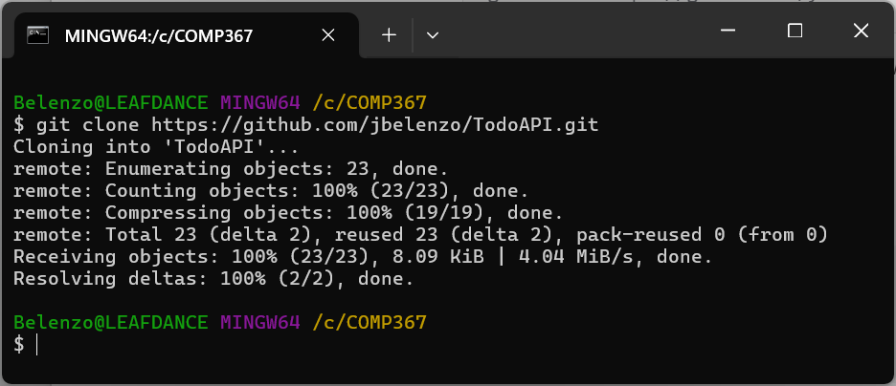

2. Create a branch protection rule for TodoAPI repository in your account to ensure that no pull request can be merged without at least one member's approval [1 mark]

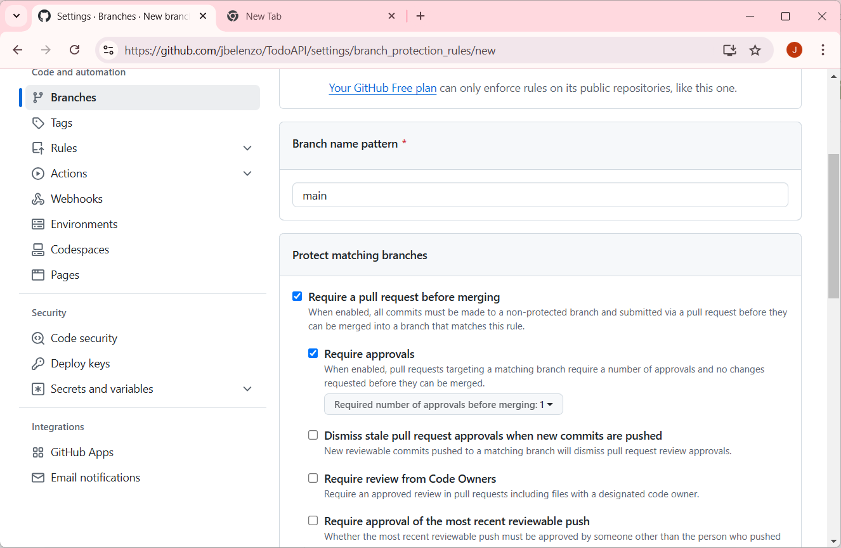

3. Add a collaborator (e.g., your another github account) [1 mark]

4. Create an issue to update data items of TodoItems (e.g., add quiz#2), label the issue as "Enhancement", assign the issue to yourself [1 mark]

5. Create a branch [1 mark]

6. Update C# code to fix the issue created in 4) [1 mark]

7. Commit your work with proper comments to make sure that the issue will be closed after your work has been successfully merged [1 mark]

8. Open a Pull Request, and add the collaborator added in 3) as a reviewer [1 mark]

